Integrating IoT and ML for Precision Agriculture

Arti Yadav¹
¹PG Research Student
Department of Electronics & Telecommunication,
JSPM’s JSCOE, Hadapsar, Pune -411028
artiny29@gmail.com
Dr.D.B.Salunke²
²Research Guide
Department of Electronics & Telecommunication,
JSPM’s JSCOE, Hadapsar, Pune -411028
dbsalunke@rediffmail.com

Abstract— An in-depth interdisciplinary study explores the latest progress in digital agriculture by utilizing artificial intelligence (AI), machine learning (ML), and Internet of Things (IoT) technologies. Agriculture plays a vital role in the Indian economy. However, population growth and food shortages pose significant challenges to sustainable development. To address these issues, modern technologies such as AI, IoT, and precision agriculture analytics are being integrated into farming practices. By adopting these innovative approaches, the goal is to empower farmers to adapt to changing conditions while minimizing their environmental impact.
The medium that challenges this cutting- edge technology is “machine learning (ML)”. Despite that, crop yields are determined by various factors, including quality of soil, rainfall, seed type, and weather. Moreover, while fertilizers and pesticides are necessary to increase crop yield, these chemicals can pose health dangers to farmers who work with them. The main Objective of precision agriculture is the collection of information from different sources, which enables farmers to make decisions regarding their crops and soil based on current live data. The relevance of precision agriculture is underscored by its prospects in boosting output while minimizing negative environmental effects, as well as saving resources through accurate application of water, fertilizers, and pesticides. Combining lot and machine learning offers farmers the possibility to improve the results of their practices in predicting the yield of crops and preventing problems from becoming serious issues, thus making farming more effective and environmentally friendly.

Keywords—: PA (Precision Agriculture), “SVM (Support Vector Machine)”, “RF (Random Forest)”, IoT (Internet of Things) DSS (Decision Support System), Supervised Learning Model

Introduction
Precision agriculture (PA) represents a modern farming management concept that leverages technology to optimize field-level crop management. Central to PA is the utilization of data from various sources, allowing Growers to make reasonable decisions based on real- time track information related to their crops and soil. The importance of PA lies in its implicit to maximize crop yields, minimize environmental impact, and conserve coffers through precise operations of water, fertilizers, and pesticides. By integrating lot and machine learning, farmers can enhance the accuracy of their operations, predicting crop performance and identifying issues before they escalate, thus transforming traditional agriculture into a more efficient and sustainable practice.[5] This paper will attempt to propose a solution-oriented way forward towards empowering the Indian farmer to construct an integrated crop and soil advisory system. It considers all the critical agronomic parameters like [2] “nitrogen”, “phosphorus”, “potassium level” [NPK], soil pH temperature, humidity, and Climate change and predicts what types of crops can be grown based on that environmental condition. [1] the recommendations of the soils best suited to optimize the yield of each of these crops. These goals will be achieved using a chain of machine learning models which are the focus of all the research above which includes “Support Vector Machines” (SVM), “Decision Tree”, Extra Trees, “Random Forest. The choice of the respective model was based on their interaction supersensitive with very large, convoluted data sets generally with high dimensional as stated in agriculture, the Random Forest model was reported to be quite effective despite being particularly well-suited for recommendatory scenario for picking ideal crop and congenial soil type. That is why Random Forest works in most all applications, because you can feed it a few dozen variable and it just does its thing without getting crazy. This where it builds a multitude of decision trees in the training phase. So finally, in giving the final prediction it gives us the most popular category, so we get highest accuracy and reliable. [3] The reason why machine learning is important in Agriculture, and the kind of difference it can make to the model performance. It provides users with a possibility to complement traditional farming methodologies, thereby benefitting resource utilization, maximizing yield, and ensuring greater and sustainable practices. To illustrate information of the existing ML models used for crop selection.

Literature Review
The integration of the “Internet of Thongs”( IoT) in Precision Agriculture( PA) has converted traditional farming practices by enabling real- time data collection, automated decision-making, and resource optimization. [14]Several studies highlight the role of IoT-based sensors, wireless networks, and “machine learning” (ML) algorithms in improving crop monitoring, soil management, irrigation efficiency, and pest detection. Researchers emphasize that remote sensing technologies, including UAVs and GPS-based monitoring systems, facilitate precise field analysis, enhancing productivity while minimizing environmental impact.
Furthermore, Big Data analytics and artificial intelligence (AI) techniques, such as Support Vector Machines (SVMs), deep learning, and predictive modelling, are increasingly being employed to analyse complex agricultural datasets. Studies suggest that IoT-enabled systems significantly contribute to yield prediction, disease detection, and decision support systems (DSS). However, existing literature also highlights critical challenges, including data security risks, interoperability issues among IoT devices, and high implementation costs.
Despite these limitations, recent advancements in AI-driven analytics, blockchain for data security, and cloud-based IoT architectures indicate promising future developments in PA.

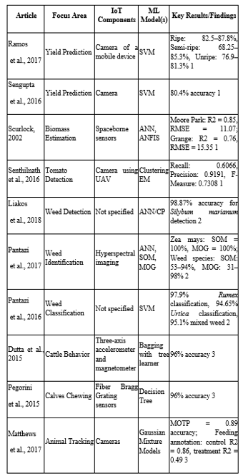

Table 1. Literature Survey

Smart Farming or Precision Farming

Smart agriculture or precision farming is the use of cutting-edge technologies like the Internet of Things (IoT), sensors, artificial intelligence (AI), and cloud computing to increase agricultural efficiency, productivity, and sustainability through making data-driven decisions [10]. This involves the use of advanced Information and Communication Technology (ICT) tools in various agricultural activities, including real-time monitoring of crops, aquaculture, snail rearing, and traditional crop rearing.
All these technology systems are integrated by gathering information on environmental conditions, soil conditions, crop yields, and livestock movement using smart sensors and networked devices. Then, the gathered data is processed using artificial intelligence to enable planning, management, and optimization of farm operations.
In simple words, smart farming is the implementation of digital instruments—hardware as well as software—into agricultural operations to reap the maximum amount of crop with optimal utilization of resources. As technology advances, the future of agriculture is predicted to rely increasingly on intelligent sensing, analytics, and automated control systems, revolutionizing agricultural activities further [12].
Figure.1 Smart Farming
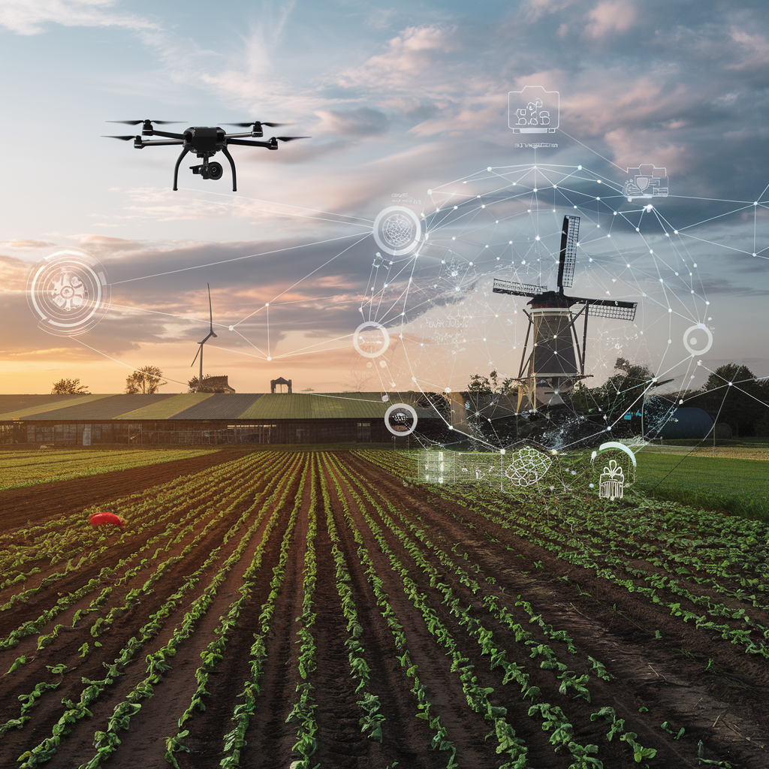
- Soil Management:
Precision agriculture focuses on providing plants with the necessary resources for growth, including water, nutrients, temperature, and oxygen, and utilizes wireless sensor nodes to gather soil data. Advanced machine learning algorithms can forecast and evaluate soil characteristics, impacting decisions related to crop and seed selection, land preparation and fertilizer applicationThe ability to predict and identify soil properties is important as it affects a variety of aspects, including plant and seed selection, the use of soil changes (organic or synthetic), and estimates of harvest times and yields. Implementing this approach minimizes the costs associated with fertilizer use and eliminates the need for comprehensive soil testing. Additionally, experts can help increase income and improve soil quality.
Advanced learning algorithms were used to predict nutrient levels in bedless media, promote cultivation, and at the same time reduce the need for manual work. [14]This model was used by scientists to calculate the amount of SO and HâPO in the nutrient solution. Researchers found the accuracy of the average level when determining soil moisture levels using machine learning techniques.

- Crop Management:
- Accurate yield prediction:
before harvest enables farmers to minimize production costs and empowers governments to plan ahead. ML applications can tally the number of fruits on trees and classify them based on their level of ripeness.
    - disease detection: integrating iot, ml, and ai optimizes pesticide application by detecting diseases in real time Systems employ sensors to gather environmental information and algorithms to forecast weather patterns and identify parasites.
    - weed detection: ml algorithms and sensors can distinguish weeds from crops, reducing herbicide dependence Researchers have created methods for distinguishing particular weeds and crops using multispectral and hyperspectral imaging.
    - crop quality: machine learning can identify and classify elements of crop quality, leading to higher prices and less waste

- Livestock Management:
Livestock management is an important aspect of sustainable agriculture, contributing to farm income, soil fertility, and food production. Effective livestock management demands effective attention to animal care, reproduction, nutrition, and health assessment of animals like cattle, goats, sheep, poultry, and pigs. Efficient livestock systems can improve agricultural productivity by utilizing manure as an organic fertilizer, thereby improving soil quality and crop yields. Moreover, the integration of livestock with crop farming enables the maintenance of a balanced ecosystem, minimizes waste, and maximizes overall farm efficiency. Advanced technologies, such as automated feeding systems, health monitoring, and data-driven breeding programs, are further improving livestock management practices to achieve improved profitability and environmental sustainability.

Methodology


Figure 2. process to be followd for smart Agriculture

- Data Collection:
Utilizing sensors and IoT devices to collect real-time information on soil conditions, crop health, weather, and livestock performance, and other key factors.
- Data Analysis:
Utilizing AI and machine learning algorithms to process the collected data and derive patterns, trends, and insights to guide decision-making.
- Automation and Robotics:
Employing autonomous systems and machines to do the work such as planting, harvesting, watering, and pest control, enhancing productivity and lowering Labor expenses.
- Remote Monitoring and Control:
Providing farmers with the capability to monitor and manage their operations remotely using network device and platforms, enhancing convenience and decision making.
- Smart Agriculture
Emphasizing farming practices that are productive and sustainable, attempting to reduce climate change and improve vulnerability to extreme weather conditions.

“Machine Learning” Model for “Precision Agriculture”
Machine learning in precision agriculture is revolutionizing conventional farming by allowing data-driven decisions, maximizing resource utilization, and enhancing productivity. Supervised models such as Random Forest and SVM are good for classification problems, but deep learning models (CNN, RNN) are transforming disease detection, weather forecasting, and autonomous farming. The convergence of IoT, edge computing, and reinforcement learning further enables self-reliant farming.[9] currently, with the advent of advanced algorithms and huge data sets via internet resources, industries and studies organizations are making significant use of ML algorithms for resolving a extensive sort of issues. DL is the department of the family of ML algorithms this is skilled from massive sets and employs an artificial neural network (ANN) to make smart selections. “Supervised learning” because the name suggests is mastering with the trainer or supervisor. This collection of algorithms operates on labelled information-set that is, for every input there are outputs. The algorithm constructs an input-output relationship the use of this labelled data set and then generalize or predicts outputs for unknown inputs. “Supervised learning algorithms” employed for predicting the specific value are referred to as class algorithms and the algorithms employed for predicting the numerical value are referred to as regression algorithms. Unsupervised learning algorithms perform on unlabelled information and learns unknown objects through clustering similar objects.
The objective of an unsupervised learning algorithm is to learn the underlying knowledge from the training data set hence this method is challenging to implement compared to supervised learning algorithms. Reinforcement learning is another method that learns from the environment by reward and punishment.
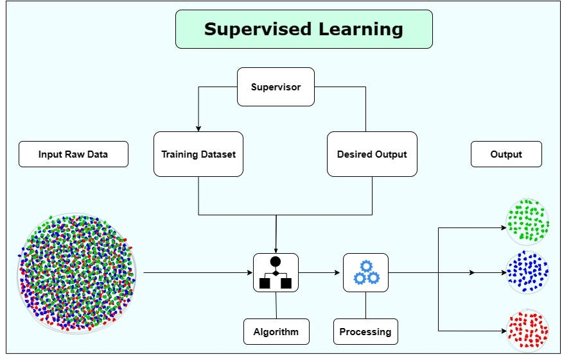
Figure 3 Supervised learning
The learning process of the control training model contains systematically adjusted weights and reduces the difference between the model prediction and the actual value of the target variable in the desired data set These advantages of learning are often called exact settings. The learning course provides a controlled educational model that can study the patterns and relationships of the data in order to summarize the goal variables for the invisible data in the past. Previously, the ability of control education models that make effective predictions depends mainly on the quality and various indicators used to teach the model

Solving key agricultural challenges using ML techniques
• Low yields:
By using machine learning farmers can determine the best times for planting and watering crops while predicting perfect growth conditions.
• Pest and disease outbreaks:
Early warning systems utilize machine learning to provide farmers with alerts about possible disease outbreaks. Machine learning enables researchers to create models that forecast pest and disease spread.
• Soil degradation:
Machine learning enables farmers to detect degraded soil areas and develop soil improvement management plans.
• Water scarcity:
Machine learning enables farmers to create efficient irrigation schedules while locating alternative water supplies.
• Climate change:
Machine learning enables farmers to adjust to environmental changes as it provides optimal growing condition data and establishes early warning systems for severe weather events..

Benefits of Machine Learning for agriculture
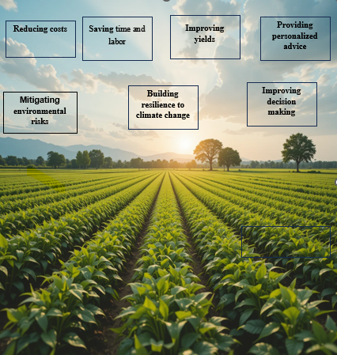
Figure.3 Benefits of using ML and IoT for Agriculture

- Mitigating environmental risks
Machine learning enables farmers to fine-tune their irrigation timing, fertilizer quantities, and pesticide usage which helps minimize waste and protect the environment.
- Saving time and labor
Machine learning technology automates the processes of field mapping along with crop health surveillance and fertilizer application. Through machine learning farmers can spend less time working and save money while decreasing their dependency on hired workers.
- Improving yields
Farmers use ML to optimize their resources which leads to higher crop production. This strategy leads to better food security and decreases hunger rates.
- 4. Reducing costs
Through machine learning farmers achieve cost savings by reducing their expenses on essential agricultural inputs such as water and chemicals. Machine learning applications in farming boost profitability while supporting long-term agricultural sustainability.
- Improving decision making
Farmers benefit from machine learning because it supports more accurate decisions regarding planting times and irrigation methods as well as fertilizer application periods.
- Enhancing safety
Through machine learning farmers can eliminate dangerous tasks like pesticide application. The implementation of these practices will lead to enhanced safety and health conditions for farm workers.
- Providing personalized advice
Machine learning offers farmers customized suggestions for planting schedules as well as irrigation and fertilization techniques.
- Building resilience to climate change
ML enables farmers to modify their agricultural practices to respond to shifting weather conditions thereby developing climate change resilience.

List of Machine Learning model

with Performance

Precision agriculture (PA) leverages machine learning (ML) models to analyse large datasets from sensors, satellites, and IoT devices to enhance decision-making in crop management, irrigation, soil analysis, and pest control. Below, we discuss key ML models applied in PA, their applications, and challenges.
This study investigates the effects of various machine learning algorithms on agriculture. Table 2 shows the soil and weather conditions, detect diseases and weeds, use wise irrig-ation and harvest methods, and show exaggerated controlled, uncontrolled and enhanced learning algorithms of crop management.
Table 2: Performance Metrics for ML algorithm in Farming Sector
Algorithm | ML Algorithm and performance
Algorithm | Application | Performance Metrics
Extreme Learning Machine (ELM) | Predicting soil surface humidity | RMSE = 2.19%  Or above
Random Forest (RF) | Predicting soil organic carbon (SOC) | R² = 0.60, RMSE = 0.35% or above
Support Vector Regression (SVR) | Soil water retention prediction | Best under wet and dry conditions
Deep Belief Network (DBN) + Macroscopic Cellular Automata (MCA) | Predicting soil moisture content | Lower RMSE than MLP-MCA
Artificial Neural Network (ANN) | Soil temperature prediction | Accuracy > 95%
Extreme Learning Machine (ELM) | Predicting soil surface humidity | RMSE = 2.19% or above
Random Forest (RF) | Predicting soil organic carbon (SOC) | R² = 0.60, RMSE = 0.35%
Support Vector Regression (SVR) | Soil water retention prediction | Best under wet and dry conditions
Deep Belief Network (DBN) + Macroscopic Cellular Automata (MCA) | Predicting soil moisture content | Lower RMSE than MLP-MCA

Scope and Limitation
IoT and ML integration in precision agriculture encompasses a wide extent of practices, from keep track of crop soil health assessment and environmental management, but it is constrained by several factors. Key challenges include data interoperability due to the diversity of sensor technologies,
the potential for high initial investment costs, and the need for robust data security frameworks. Additionally, rural areas may face connectivity issues, hampering real-time data transmission and accessibility. Variability in local farming conditions further complicates the development of universally applicable models, necessitating tailored solutions that can adapt to specific agricultural contexts and regulatory environments.
Agriculturalists face several challenges when adopting precision agriculture technologies. These include the harsh environmental conditions that affect the devices used in the Internet of Things (IoT), which can damage electronic circuits. Additionally, determining the precise resource requirements is complicated by the changing nature of farm Areas and sensor analysis. The limited resources in Internet Of Things systems, along with the need for powerful resources and smart sensors, can lead to higher energy consumption, making them crucial for maximizing agricultural output and minimizing costs.

Challenges
Internet of Things (IoT) sensing devices face several challenges in outdoor agricultural environments, primarily due to their exposure to harsh conditions that can damage sensors and gateways, leading to communication failures. Additionally, these devices are vulnerable to environmental tampering, including attacks from animals and theft, which further compromises their reliability and security. Limited resources such as memory, processing power, and communication capabilities also restrict the use of complex algorithms necessary for effective operation in precision agriculture.
- prediction depends on the quality of the training dataset but limited crop types.
- Because training of the system greatly contributes to the performance of the system, unlevelled data can lead to catastrophic prediction systems.
- Overtraining a model can cause sensitive prediction system

References
- K. Garza, C. Goble, J. Brooke, and C. Jay, “Framing the community data system interface,” Proceedings of the 2015 British HCI Conference. ACM, Jul. 13, 2015.
- Sita Rani, Amit Kumar Mishra, Aman Kataria, Saurav Mallik & Hong Qin Scientific Reports volume 13, Article number: 15997 (2023)
- Akhter R, Sofi SA. Precision agriculture using IoT data analytics and machine learning. J King Saud Univ Sci. 2022;34(8):5602-5618.[Crossref] [Google Scholar]
- Ravesa Akhter ,National Institute of Technology Srinagar
- Zaiba Khan, Department of Computer Science, RNB Global University, Bikaner, Rajasthan, Indi
- Rodriguez-Galiano, V.; Sanchez-Castillo, M.; Chica-Olmo, M.; Chica-Rivas, M. Machine learning predictive models for mineral prospectivity: An evaluation of neural networks, random forest, regression trees and support vector machines. Ore Geol. Rev. 2015, 71, 804–818. [Google Scholar] [CrossRef]
- Uyanık, G.K.; Güler, N. A Study on Multiple Linear Regression Analysis. Procedia-Soc. Behav. Sci. 2013, 106, 234–240. [Google Scholar] [CrossRef] [Green Version]
- Radhika, Y.; Shashi, M. Atmospheric Temperature Prediction using Support Vector Machines. Int. J. Comput. Theory Eng. 2009, 1, 55–58. [Google Scholar] [CrossRef] [Green Version]
- ABHINAV SHARMA 1 , ARPIT JAIN 1 , PRATEEK GUPTA2 , (Student Member, IEEE), AND VINAY CHOWDARY 1 ,Machine Learning Applications for Precision Agriculture: A Comprehensive Review: Digital Object Identifier 10.1109/ACCESS.2020.3048415
- farmingRavi Ray Chaudhari,1* Kalyan Devappa Bamane,2 Himanshi Agrawal,3 P. Malathi,2 Aarti S. Gaikwad,2 Abhijit Janardan Patankar2 A critical analysis of crop management using Machine Learning towards smart and precise J. Integr. Sci. Technol.2024, 12(5),80
- K. Jha, A. Doshi, P. Patel, and M. Shah, ‘‘A comprehensive review on automation in agriculture using artificial intelligence,’’ Artif. Intell. Agricult., vol. 2, pp. 1–12, Jun. 2019
- Authors: Achim WalterRobert Finger,ETH Zurich,Robert Huber ,ETH ZurichNina Buchmann ,ETH Zurich Opinion: Smart farming is key to developing sustainable agriculture Proceedings of the National Academy of Sciences 114(24):6148-6150
DOI:10.1073/pnas.17074621,14 June 2017
N. Raghava Rao, Madhuri Kovoor, G. Nanda Kishor Kuma, D.V. Lalita Parameswari International Journal on Recent and Innovation Trends in Computing and CommunicationISSN: 2321-8169 Volume: 11 Issue: 7s DOI: https://doi.org/10.17762/ijritcc.v11i7s.7006A, 05June 2023
- Geo Abraham; Raksha R.; M. Nithya 2021 5th International Conference on Computing Methodologies and Communication (ICCMC)DOI:10.1109/ICCMC51019.2021.9418392,Date-06May 21
- Tanzania Journal of Engineering and Technology 2023, 42(4): 30 - 45 OPEN ACCESS articles distributed under Creative Commons Attribution Licence [CC BY-ND] Websites: https://ajol.org/tjet; https://tjet.udsm.ac.tz
- Comprehensive Survey on Applications of Internet of Things, Machine Learning and Artificial Intelligence in Precision Agriculture" are Doreen Thotho and Paul Stone Macheso 1. Doreen Thotho is affiliated with the African Center of Excellence in Internet of Things (ACEIoT), University of Rwanda, College of Science and Technology, Kigali, Rwanda 1. Paul Stone Macheso is with the Department of Physics & Electronics, University of Malawi, Zomba, Malawi 1. The corresponding author is Paul Stone Macheso, and their email is pmacheso@unima.ac.mw 1, 2. The ORCID for Paul Stone Macheso is https://orcid.org/0000-0001-5060-306X
- Sharma et al. (2020) present a comprehensive review of machine learning applications for precision agriculture 4
A. (2021). Smart Irrigation System Based on the Internet of Things and the Cloud. Int. J. Mod. Trends Sci. Technol, 7(9), 19-24. Madhumathi, R., Arumuganathan, T., & Shruthi, R. (2022). Internet of things in precision agriculture

Scopus ID: 57226019017

